How I make my decisions

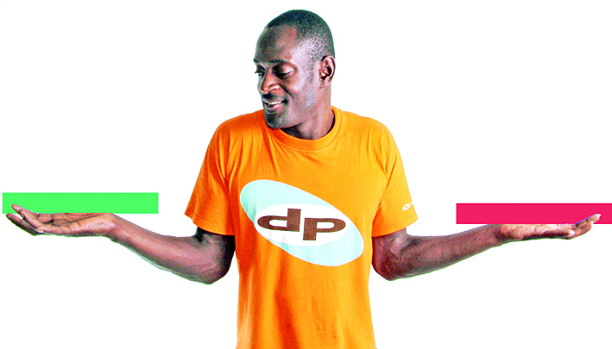

Please look at this form.

This form says:
- who I want to support me with my decisions

- what sort of support I need.
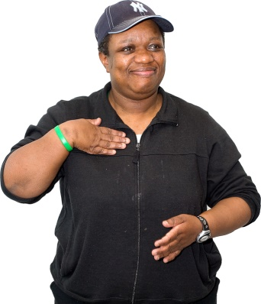
My name is:

______________________________________

My address is

______________________________________

______________________________________

______________________________________

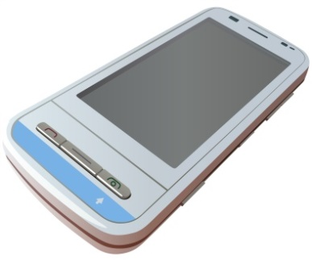
My phone number is:

______________________________________

This form will assist the people in your life to
know how you make decisions.

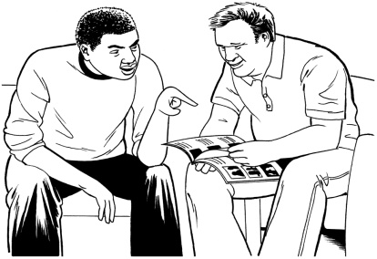
Fill this form in by yourself or with the people who support you.

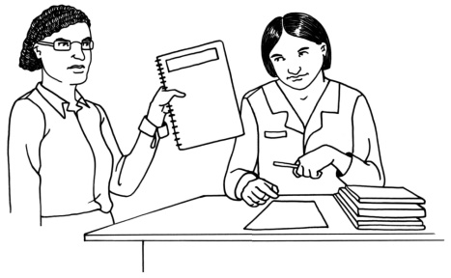
Give this form to your disability support service and anyone else you think needs to have it.

Tick the boxes that are right for you.

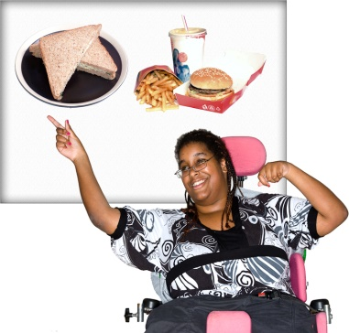
I make every day decisions like what I eat and what I wear:

by myself
with support from

_____________________________

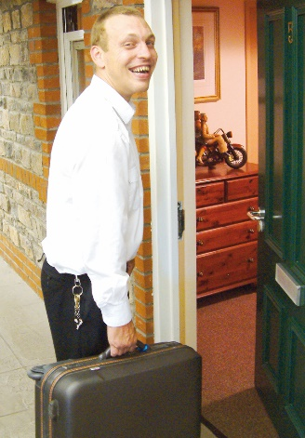
I make decisions that are a bit bigger like going on holiday or joining a club:

by myself

with support from

_____________________________
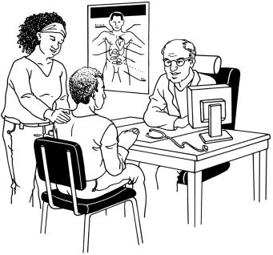
I make very big decisions like about my health, where I live and who I live with:

by myself

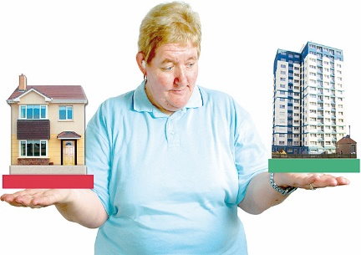
with support from

_____________________________

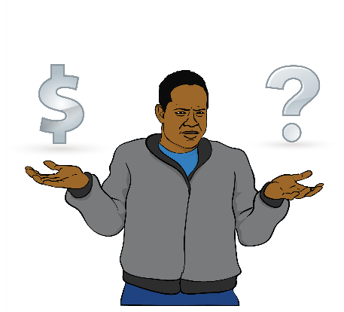
I make decisions about my money:

by myself

with support from

_____________________________

To make my decisions I need:

information in ways I can understand

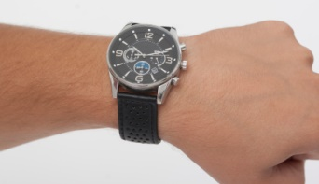
time

information about what will happen if I decide yes

information about what will happen if I decide no

to have a real life experience.

This is a space to write down any other things you need to make decisions:

__________________________________________________

__________________________________________________

__________________________________________________

__________________________________________________

__________________________________________________

__________________________________________________

__________________________________________________

__________________________________________________

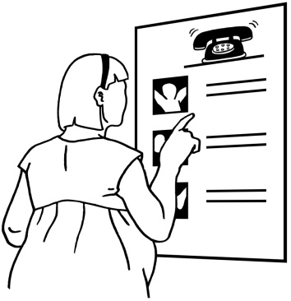
Important:
Here are the names and contacts of the people who support me to make my decisions.

This is 1 of the people who supports me:
Name:

__________________________________

How to contact them:

___________________________________

___________________________________

This is another person who supports me:
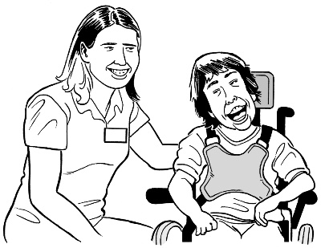
Name:

__________________________________

How to contact them:

___________________________________

___________________________________

This is another person who supports me:
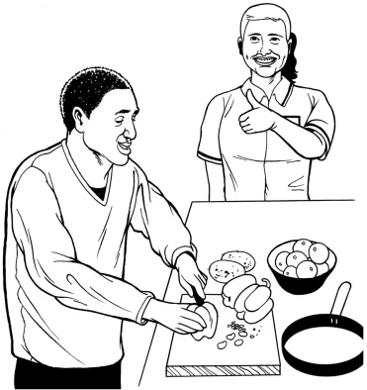
Name:

__________________________________

How to contact them:
___________________________________

___________________________________

This is another person who supports me:
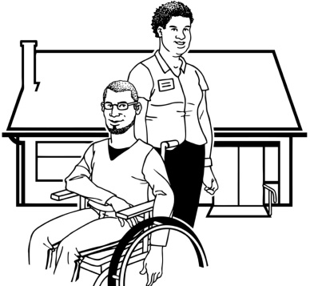
Name:

__________________________________

How to contact them:
___________________________________

___________________________________

This is another person who supports me:
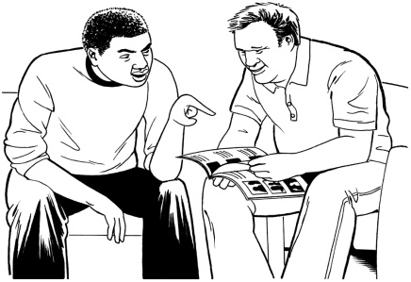
Name:

__________________________________

How to contact them:
___________________________________

___________________________________

This information has been made
by People First New Zealand Inc. Ngā Tāngata Tuatahi

